**LAB 3 CMD COMMANDS**

**JavafxSample.java**

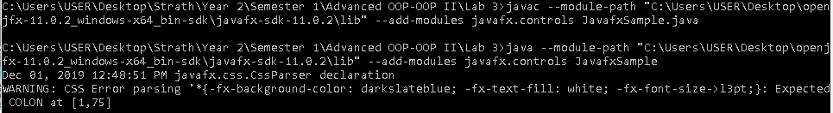

**Customers.java**

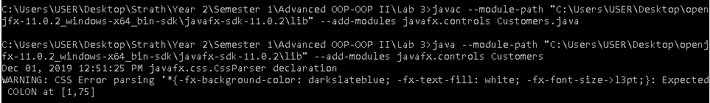

**Movies.java**

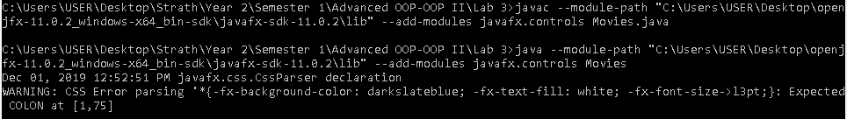

**Rentals.java**

